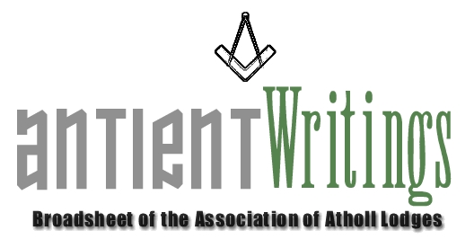

1st Edition, 2007

Dermott 2006 – Events

The six main events for the Dermott year were completed with the ‘performance and roadshow’ being taken around the country. ‘Getting the message out’ has been achieved and many brethren appreciative of the work undertaken. The Library & Museum staff at Freemasons Hall, London are to be commended for their efforts with the exhibition.

A Brothers Assistant – The Laurence Dermott Story

The 40 page illustrated book is still available, telling the story of Laurence Dermott. If you would like a copy please contact the Secretary. They are £6 inc P & P.

Annual General Meeting

The 2007 Annual General Meeting will be held at FM Hall Great Queen Street London on Wed 4th July starting at 6pm. All are welcome. Should any subscribing lodge wish to bring forward a ‘Notice of Motion’ please submit it in writing to the Secretary by 4th June 2007.

New Hope – Rescue a Lodge

If you are a struggling Atholl lodge bereft of members facing the stark reality of erasure – don’t despair. The Secretary is aware of a group of ‘Atholl’ enthusiasts who are willing to ‘rescue’ such a lodge rather than let it be lost. The plan would be to enrich its membership and move it to Sindlesham, Berkshire where it would have a safe and secure home and future. Further information is available through a link contact via the Secretary.

New Vice President

We are pleased to announce the appointment of a new Vice President – W.Bro. Yasha Beresiner has agreed to be a VP and hopes to be able to assist the Association at future events. He is a well known historian and commentator on Masonic matters and a respected after dinner speaker. He will be a great asset to the Atholl family.

Web Site - www.antients.com

The website has had a make over and Neil, the webmaster is keen to enhance the ‘Regions’ pages to include ‘info’ and ‘chat’ from any Atholls around the country. Please send any submissions to him at: webmaster@antients.com

Midlands Meeting

It has been suggested that one of the Executive meeting be held ‘around the country’ and to that end it is hoped to arrange one for the Midlands sometime in the future. Would any lodge interested in hosting such a meeting please make contact with the Secretary to facilitate planning and maybe give consideration to ‘bolting’ to it some sort of general Atholl event. A talk or Lodge meeting perhaps!

New Blood

If you are interested in joining the Executive Committee, which meets 3 times a year in London with the possibility in future of having one meeting out of London. Please make contact with the Secretary who is always keen to involve new blood and share common antient interests with Atholl brethren.

Would Secretaries and Representatives photocopy and distribute as widely as possible

Paul Gardner - 39 Wentworth Drive, Bedford, BEDS, MK41 8QA - 01234 261584 - secretary@antients.com

